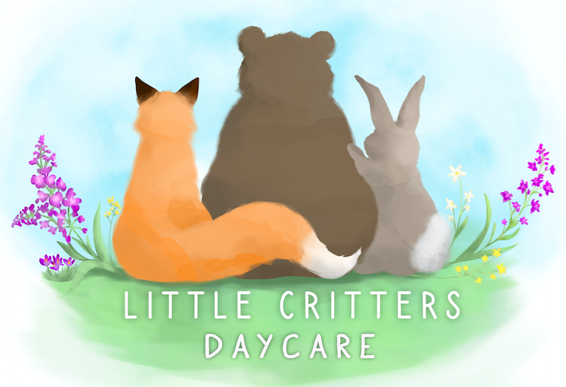

On-call Educator

This position:
- Provides an introduction to the field
- Allows for flexible hours/scheduling
- Does not require the successful applicant to continue education in ECE
- Works closely with ECEs to provide fun, inclusive, and engaging opportunities for children

Full-Time Or Par-Time Educator

We would love to hear from any individual who enjoys working with children, is willing to learn and be part of a team!
Wage will be determined by the level of education and years of experience. Full health benefit package available.

For more information or to submit your resume and cover letter, you can contact us at: yukoncritters@gmail.com

Follow us on Facebook @ LC Daycare

