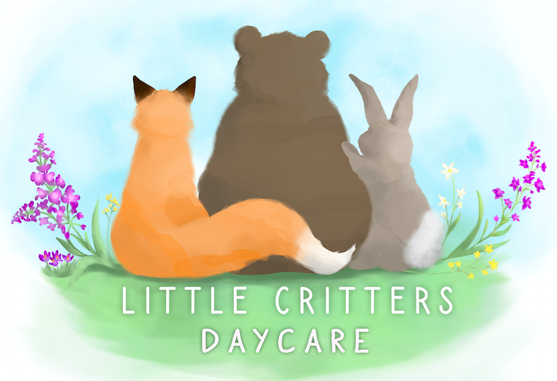

We are looking to hire an On-call Educator

This position:
- Provides an introduction to the field
- Allows for flexible hours/scheduling
- Does not require the successful applicant to continue education in ECE
- Works closely with ECEs to provide fun, inclusive, and engaging opportunities for children

For more information or to submit your resume and cover letter, you can contact us at: yukoncritters@gmail.com

Follow us on Facebook @ LC Daycare

